TYPE CASTING IN JAVA
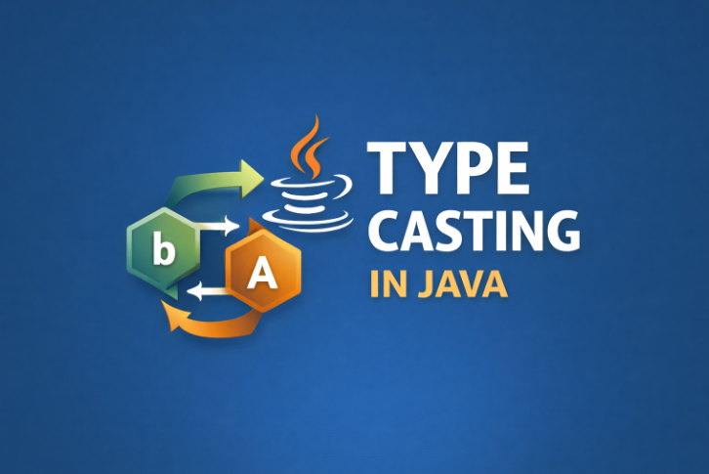

🔄 Type Casting in Java (Simple Explanation)
Today I learned about Type Casting in Java.

What is Type Casting?
Type Casting means converting one data type into another data type.
Sometimes in programming we need to store a value of one type into another type variable.
To do this, Java allows type conversion, which is called Type Casting.
Example:
Convert int → double
Convert double → int

🔹 Why Type Casting is Needed?
Type casting is used when:
• We want to store a value in a different data type
• We want to perform calculations with different types
• We want to reduce memory usage
• We want precise control over data conversion

🔹 Types of Type Casting in Java
Java has two types of Type Casting:
1. Widening Casting (Implicit Casting)
2. Narrowing Casting (Explicit Casting)

1. Widening Casting (Implicit casting)
Widening casting happens when a smaller data type is converted into a larger data type automatically.
📌 Java does this automatically, so we do not need to write any special code.
Example Conversion Order
byte → short → int → long → float → double
💻 Example Code :
public class WideningCasting {
public static void main(String[] args) {
int number = 25;
double result = number; // automatic conversion
System.out.println(number);
System.out.println(result);
}
}
📌 Output
25
25.0
Important Points
• Done automatically by Java
• No data loss
• Safe conversion
• Smaller → Bigger data type

2.Narrowing Casting (Manual)
Narrowing casting happens when a larger data type is converted into a smaller data type.
Java cannot do this automatically, so we must write the data type in brackets.
Conversion Order
double → float → long → int → short → byte
💻 Example Code
public class NarrowingCasting {
public static void main(String[] args) {
double number = 19.99;
int result = (int) number; // manual casting
System.out.println(number);
System.out.println(result);
}
}
📌 Output
19.99
19

Important Points
• Must be written manually
• May cause data loss
• Decimal values may be removed
Example:
10.75 → 10

Difference Between Implicit and Explicit Type Casting in Java
Feature | Implicit Type Casting | Explicit Type Casting
Another Name | Widening Casting | Narrowing Casting
Conversion | Smaller → Larger data type | Larger → Smaller data type
Done By | Java automatically | Programmer manually
Syntax Needed | Not required | Required (type)
Data Loss | No data loss | Possible data loss
Safety | Safe conversion | Risky conversion

🔹 Real Life Example
Imagine a big water bottle → small glass
You cannot fit all water in the glass.
Some water will be lost.
Same thing happens in Narrowing Casting.

🎯 Key Points to Remember
✔ Type Casting converts one data type to another
✔ Two types → Widening & Narrowing
✔ Widening → Automatic & Safe
✔ Narrowing → Manual & Risk of data loss
✔ Used in calculations and memory control

